Mouhammadou Dabo

April 15, 2021

CS 1675: Intro to Machine Learning

Professor Milos Hauskrecht

Problem Assignment 10

**Problem 1.** Bagging and Boosting

**Blue is training error, Red is testing error**

**x-axis:** T **y-axis:** error

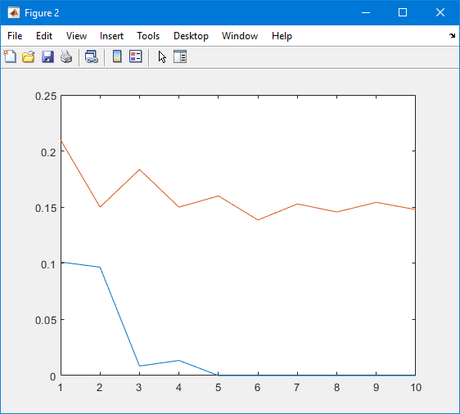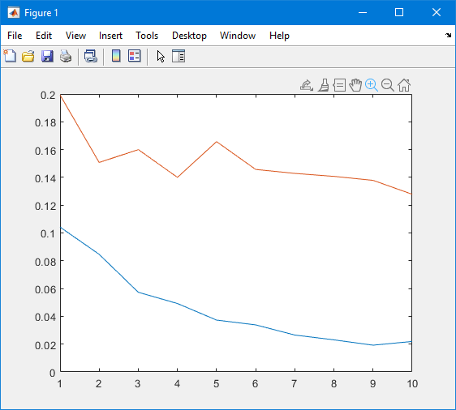**Part a.**

**Figure 1:** Bagged SVM  **Figure 2:** Boosted SVM

Analyzing the results of the bagged SVM to the boosted SVM, the testing errors of the bagged and boosted decrease as more models are added, and both hover around the same value at the end of the run. The bagged SVM training error decreases as more models are added, while the boosted SVM training error becomes 0. The test error being lower than that of the test error may be occurring due to overfitting.

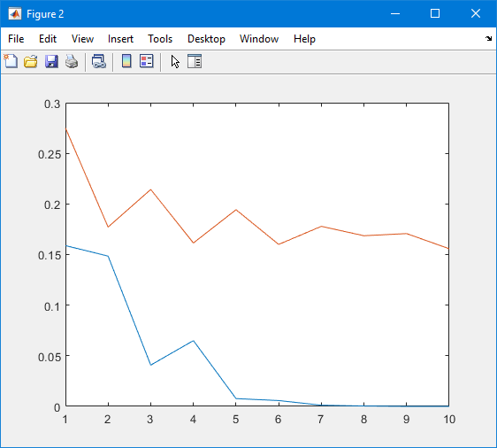**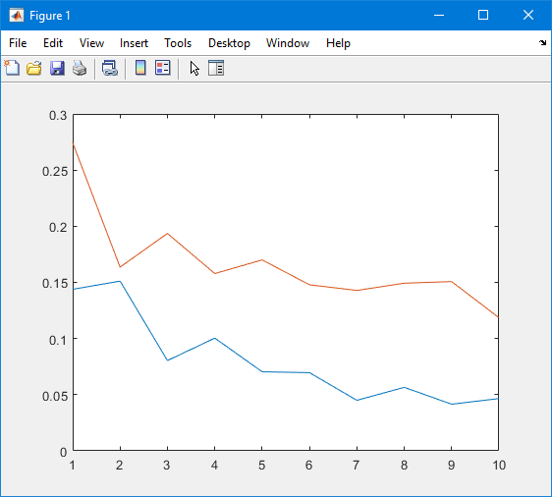Part b.**

**Figure 3:** Bagged SVM_base_full  **Figure 4:** Boosted SVM_base_full

Analyzing the results of bagged SVM_base_full and boosted SVM_base_full,, they are very similar to the results of the base SVM model. The training and testing errors for both decrease as more models are added, with the boosted training error becoming zero. Again, the test error being lower than the train error may be due to overfitting. The only difference being the training and testing errors of the bagged SVM_base_full being closer to each other than that of the base SVM model.

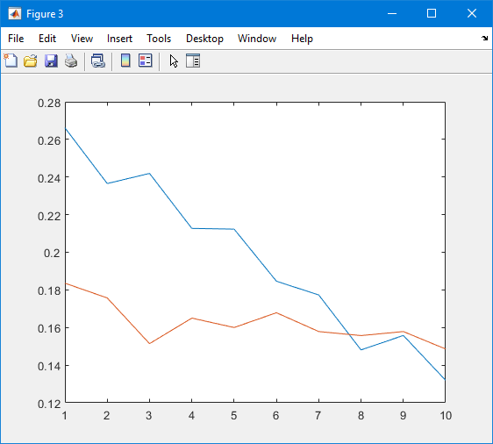**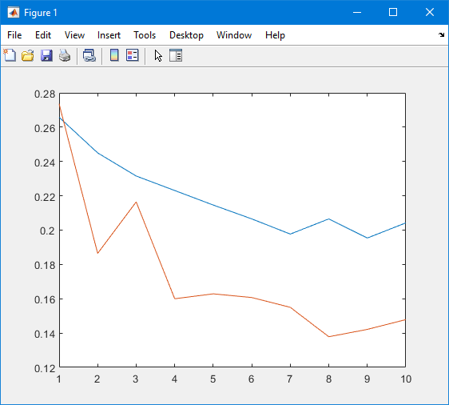Part c.**

**Figure 5:** Bagged SVM_base_simple **Figure 6:** Boosted SVM_base_simple

Analyzing the results of bagged SVM_base_simple and boosted SVM_base_simple, the results are quite different from the other. The training error is greater than that of the test error, which has not been occurring with the other examples. The idea of overfitting is not happening in this example due to the singular split. This example can be comparable to more complex models that don’t incorporate bagging.